DIGISENSOR CO.,LTD
Address : Lot I3-2, N2 Road, Saigon Hi Tech Park, District 9
Ho Chi Minh City Vietnam
Tel: (08) 3736 0721 Fax: (08) 3736 0722
Email: info@digisensor-co-ltd.com
Website: www.digisensor-co-ltd.com

PULSE COUNTER WMC-01 FOR PISTON WATER METER WITH WIRELESS MBUS
AND NFC INTERFACE

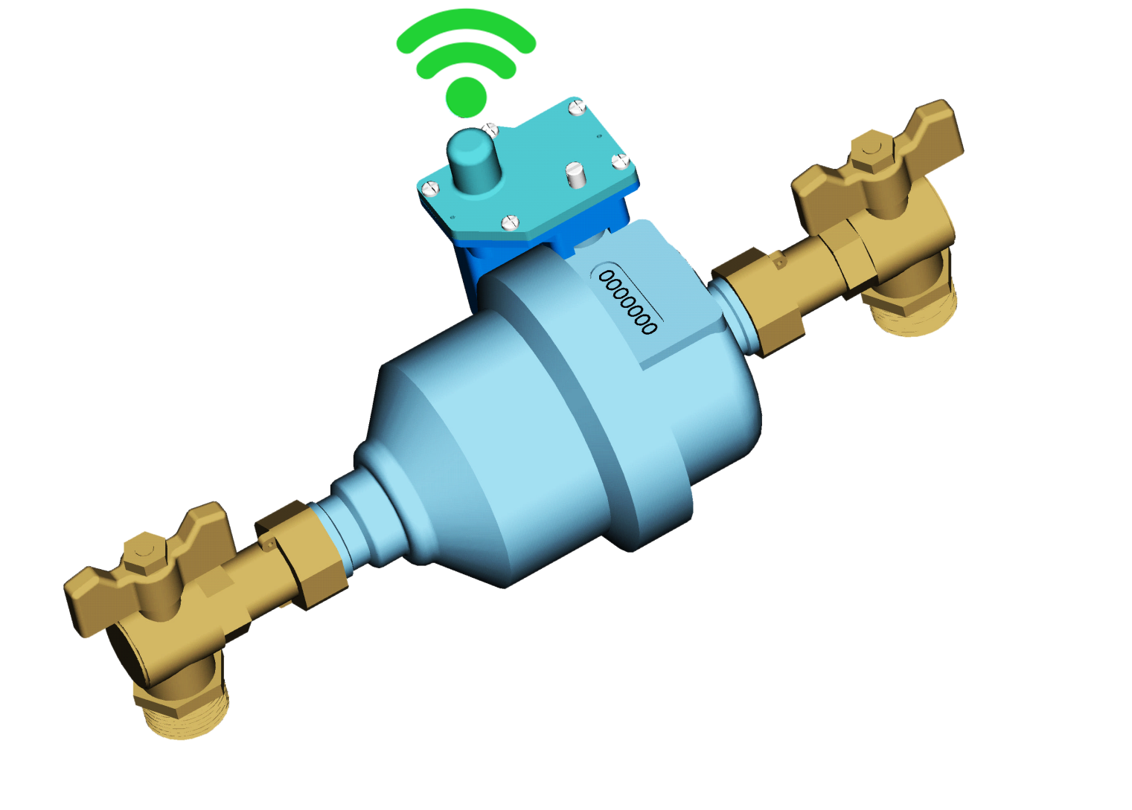

I. Description
The electronic counter WMC-01 is a pulse counter to be connected to a piston water meter.
The water volume is measured by a counter using a TMR sensor with a very low current consumption. The equipment is attached directly to a piston water meter. The accuracy of the counter is +/- 0.5 liter.
Water volume as well as other warnings alike water leakage, overflow, and low battery warning are collected by a 868 Mhz or 433 Mhz wireless dongle that is connected to an Android smartphone.
The counter includes an internal memory that contains 1000 water volume data.
NFC interface allows water utility company to configure the counter, read out the data or user to read out data with a NFC enabled Android smartphone.

II. Technical specs:
- Water volume
- From 0 to 9999.999 m3.
- Accuracy +/- 0.5 liter
- Resolution : 1 liter
- Data sampling : 1s.
- Temperature range : 0oC to 55oC.
- Warnings :
- Low battery.
- Water leakage.
- Oveflow.
- NFC interface according to ISO 15693 RF – 13.56 MHz.
- 868 Mhz Wireless Mbus.
- Battery LiSOCL2 3.6V 2.4Ah, AA size. Life time 10 years.
- IP 68

