ULTRASONIC
WATER METER
DATA SHEET
Contents
UWM

Overview 3
Measuring principle 4
Technical specifications 5
Materials 6
Overall dimensions 7
Label information 8
Display information 9
Communications 10
Data registers 11

Overview
Ultrasonic water meters (UWM products) – used for measurement of water flow in fully charged closed conduits – are designed and produced by Digisensor Co., Ltd in Viet Nam. Based on our experience since 2000 with the development of electronic devices, UWM products offer pinpoint accuracy and longevity up to 10 years.
Applying the transit time principle of ultrasonic pulses, UWM products can perform precise measurements even at very low flowrates. In fact, minimum flowrates start as low as 3 l/h with UWM-15 or UWM-20 and 5 l/h with UWM-25.
The meters include no moving parts, which makes them resistant to mechanical wear and water impurities. The meters are also highly versatile as they can operate in both horizontal and vertical direction. All constructed materials are eco-friendly and safe for the water source.
To protect the meter from external disturbances, such as heat, coldness or humidity… all electronic components are secured separately with “silicon casting” method. Therefore, UWM products are IP68 tested and ready for both indoor and outdoor operations.
UWM products have the ability to measure reverse flow. The total amount of water consumption is updated continuously on the display with the resolution of 0.00001 m³. Along with the flow wheel which simulates the current flowrate and the advanced warning system, users can always monitor their plumping condition conveniently.
Essential information such as total amount of water consumption and warning events are saved permanently in the internal memory of the meter. For communication purposes, UWM products provide 3 methods: near field communication (NFC), wireless M-Bus communication and Long Range Wide-Area Network (LoRaWAN).

Measuring principle
The ultrasonic flow measurement is based on the transit time principle. The system includes 2 fixed reflectors and 2 ultrasonic transducers, which can both operate as a transmitter or a receiver.

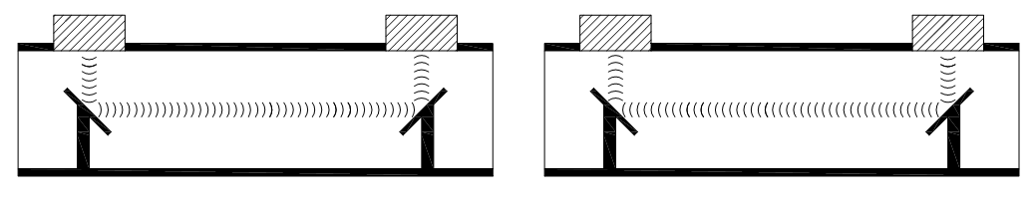
∆T = T₁ – T₂ v
T₂
T₁
v
v

The built-in micro-controller alternately transmits a signal burst (pulses) between two transducers and measures the transit time that a pulse takes to reach the other side. The difference between two transit times in then used to calculate the current flowrate.
UWM products are able to detect the time differences in the scale of pico-second, thus are suitable to measure very low flowrates and maximize the accuracy.

Technical specifications
All UWM products comply with ISO 4064:2005 standard for cold and hot potable water meters.
Severity level Class B & C
Electromagnetic environment class Class E1
Meter temperature class T50
Ambient temperature working range From +5°C to +55°C
Ambient humidity working range From 0% to 100% (at 40°C)
Water pressure class MAP 10
Ingress protection rating IP68 (IEC standards)
DC power supply 1 or 2 ER26500 lithium battery, 3.6V
Approximate battery life 5 years
Diameter [mm] | Q3  [m³/h] | Q2  [l/h] | Q1  [l/h] | Q4  [m³/h] | R=Q3/Q1 | Q min  [l/h] | Q max  [m³/h] | Pressure loss
15 | 2.5 | 16 | 10 | 3.2 | 250 | 6 | 3.7 | ∆p 63
20 | 4.0 | 25.6 | 16 | 5.0 | 250 | 10 | 6.0 | ∆p 63
25 | 6.25 | 40 | 25 | 7.8 | 250 | 16 | 9.0 | ∆p 63
40 | 10.0 | 64 | 40 | 12.5 | 250 | 25 | 15.0 | ∆p 63

Maximum permissible error
±5% at flowrate between Q₁ and Q₂
±2% at flowrate between Q₂ and Q₄ (water temperature ≤ 30°C)
±3% at flowrate between Q₂ and Q₄ (water temperature > 30°C)

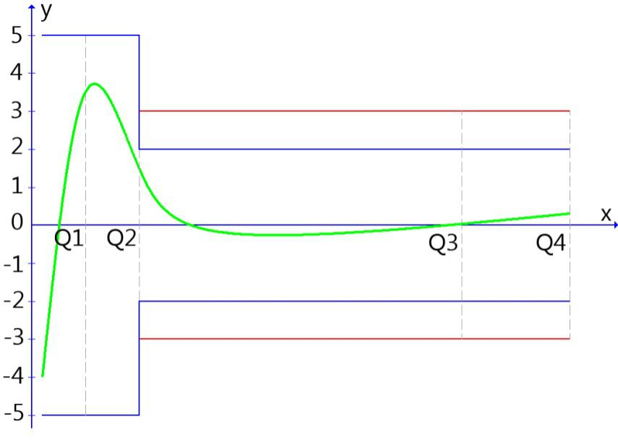
Relative error (%)

Flowrate

Materials

Dry parts
Top cover PC plastic *
Top ring PC plastic *
Top glass Acrylic
Outer case PC plastic *
Bottom cover PC plastic *
Base plate PC plastic *
Positioning bolts Brass
Ultrasonic transducers Piezoelectric materials
O-ring gaskets Rubber
Wet parts
Reflector holder PPS plastic **
Reflective pipe Stainless steel
Reflectors Stainless steel
Measuring pipe Brass

* PC plastic: Polycarbonate
** PPS plastic: Polyphenylene sulfide

Overall dimensions
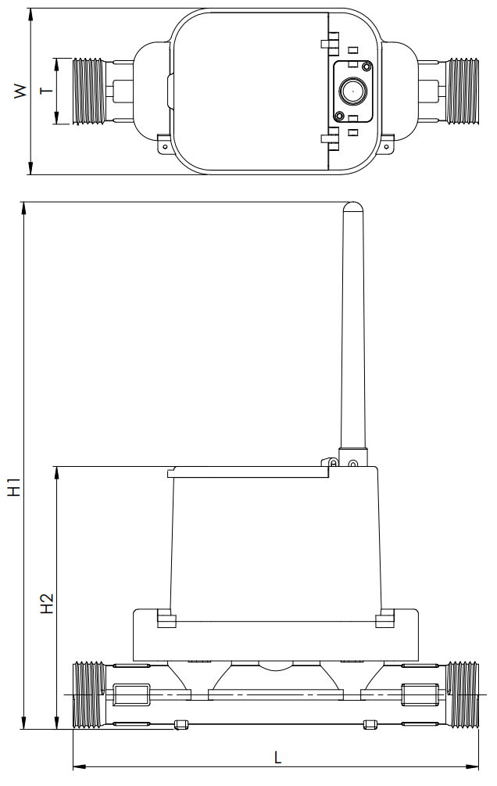
Dimensions | T (mm) | W (mm | L (mm) | H1* (mm) | H2 (mm)
UWM-15 | G3/4” B | 67 | 165 | 273 | 108
UWM-20 | G1” B | 67 | 195 | 277 | 112
UWM-25 | G1” ¼B | 67 | 160 | 287 | 122
UWM-40 | G2”1/2 B | 67 | 200 | 303 | 138
Note: (*) The height with 5 dBi antenna.

Label information
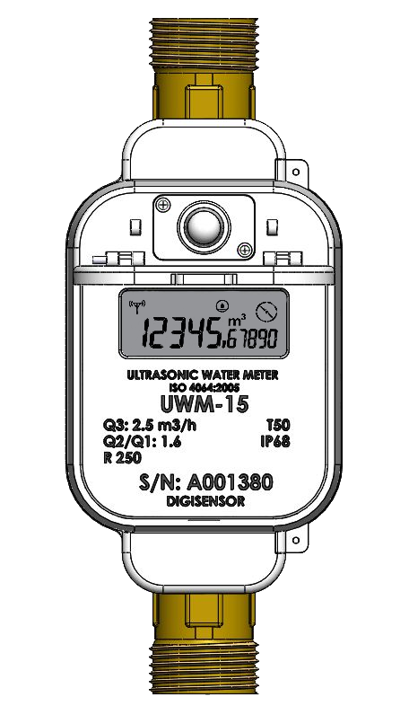

RF antenna
Regulatory compliance
Permanent flowrate
Q2/Q1 ratio
Measuring range (Q3/Q1)
NFC antenna
Product code
Serial number
Meter temperature class
Ingress protection rating

Display information
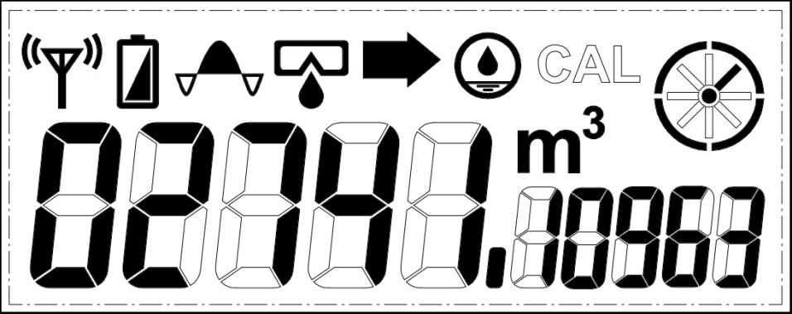
The total amount of water consumption appears permanently on the meter’s display. In detail, the five large figures indicate number of cubic meter and the five small figures are decimals.
The “CAL” symbol appears whenever the meter is in calibration mode. This mode is used during the manufacturing process only.
The meter’s display contains several warning symbols, which have the following meanings:
Symbol | Meaning
Transmitting | On: the meter is transmitting data via wireless communication  Off: the meter is not transmitting data via wireless communication
Low battery | On: the current battery voltage is lower than 3.3 VDC. Battery replacement is necessary.  Off: the current battery voltage is higher than 3.3 VDC.
Overflow | On: the current flow through the meter is higher than the overload flowrate (Q4)  Off: the current flow through the meter is lower than the overload flowrate (Q4)
Leakage | On: the water in the meter has not been stagnant for 1 continuous hour during the latest 24 hours.  Off: the water in the meter has been stagnant for at least 1 continuous hour during the latest 24 hours.
Reverse flow | On: the water is flowing through the meter in the wrong direction.  Off: the water is flowing through the meter in the correct direction.
Dry | On: water is not fully filled or is absent from the measuring pipe.  Off: water is fully filled in the measuring pipe.
Flow wheel | The flow wheel’s speed changes according to the current flow through the meter. The flow wheel spins faster at high flowrates, spins slower at low flowrates and stops when flowrate equals zero.

Communications
UWM products support 4 methods of communication, including near field communication (NFC), wireless M-Bus communication and Long Range Wide-Area Network (LoRaWAN).
NB-IoT communication available on request.
Near field communication (NFC)
Any device with NFC support, such as smart-phones or tablets can communicate with the meter. The specifications of NFC components inside UWM products are complied with ISO/IEC 15693 standard. For data reading operation, the NFC device should be placed on top of the meter as demonstrates in the picture above.
Wireless M-Bus communication
The built-in wireless M-Bus module transmits a packet of data every 2 minutes, between 6 A.M. and 6 P.M. daily. These default settings can be changed to serve different purposes. Data is available to collect by specialized receivers within the radius of 80 meters (this distance may reduce in the presence of many obstacles). Therefore, UWM products are suitable for drive-by solution, which is considered fast, economical and accurate for data collecting.
Long Range Wide-Area Network (LoRaWAN)
The built-in LoRaWAN module transmits a packet of data every 12 hours. The default settings can be changed by NFC. The UWM products support 2 LoRaWAN mode: APB and OTAA. The meter can communicate with the gateway up to 4 kilometers.
Each packet of data contains the following information:
- Meter’s serial number
- Total amount of water consumption
- Meter’s warnings
- Packet’s time

Data registers
All logging data are saved permanently inside the internal memory (EEPROM) of the meter. These logs can be accessed via near field communication only.
Registered methods
Logging interval | Logging depth | Logging instant
Hourly logger | 1 month (744 hours) | At 0 minute of each hour
Daily logger | 1 years (365 days) | At 0 hour of each day
Warning logger | 400 warnings | At warning instant

Registered information
Registered information | Hourly logger | Daily logger | Warnings logger
Day
Month
Year
Hour
Minute
Second
Low battery warning
Overflow warning
Leakage warning
Reverse flow warning
Dry warning
Total amount of water consumption

